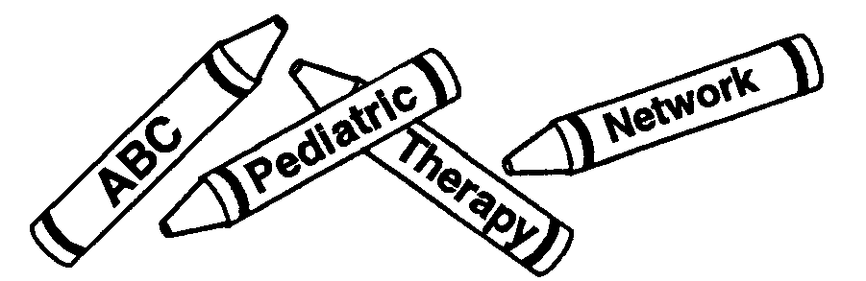

**ABC Pediatric Therapy Network**

***“Creating the best life for all children”***

**Physical Therapy Occupational Therapy Speech Therapy**

**FAX REFERRAL FORM / PRESCRIPTION**

PATIENT NAME: ______________________________________________________ DATE OF BIRTH: _______________________

GUARDIAN’S NAME: __________________________________________________ HOME PHONE #: _______________________

REASON FOR REFERRAL: Evaluate and Treat  PT  OT  Speech

PREFERRED LOCATION:  West Chester  Western Hills  Red Bank  Middletown  Miamisburg  Beavercreek

MEDICAL DIAGNOSIS:

No Known Medical Diagnosis, reason for referral: _______________________________________________________________________

ADD (F90.0)

ADHD (F90.1)

Angelman Syndrome (Q93.5)

Apraxia (R48.2)

Arthrogryposis (Q74.3)

Asperger Syndrome (F84.5)

Autism (F84.0)

Cerebral Vascular Accident

Central Auditory Processing Disorder (H93.25)

Cerebral Palsy, Unspecified (G80.9)

Chondromalacia (M94.2)

Craniosynostosis (Q75.0)

Disorder of CNS, Unspecified (G96.9)

Down Syndrome (Q90.9)

Ehler’s-Danos Syndrome (Q79.6)

Encephalopathy (G93.4)

Epilepsy, Unspecified (G40.9)

Erb’s Palsy, Monoplegia (G83.23)

Fracture

Fragile X (Q99.2)

Hemiplegia unspecified (G81.90)

Hydrocephalus, Arnold Chiari Malformation (Q07.02)

Hydrocephalus, Congenital, Unspecified (Q03.9)

Feeding Difficulties (R63.3)

**Height: __________ Weight: __________**

Juvenile Rheumatoid Arthritis

Monoplegia (G83.23)

Muscular Dystrophy (G71.0)

Osteogenesis Imperfecta (Q78.0)

Pervasive Developmental Disorder (F84.8)

Premature Birth, Birth Injury-Unspecified (P15.9)

Spina Bifida with Hydrocephalus, Unspecified (Q05.4)

Spina Bifida without Hydrocephalus, Unspecified (Q05.5)

Spinal Cord Injury

Torticollis (M43.6)

Traumatic Brain Injury

Other: ____________________________________________

PRECAUTIONS:

Infectious Disease: _____________________________________

Spinal Instability

Weight Bearing Restrictions: _____________________________

Allergy: ________________________________

Seizure Disorder

Other: ______________________________________________

REFERRAL FOR EQUIPMENT:

Orthotics  Assistive Device for Ambulation

Wheelchair Seating Recommendations  Other: ________________________________________________

**\*Please attach any relevant testing results (MBS, GI, neurological work-up, nutritionist, etc.)**

PHYSICIAN SIGNATURE:__________________________________________________DATE:_________________

PHYSICIAN NAME (print):_________________________________________________________________________

PHYSICIAN PRACTICE:___________________________________________________________________________

PRACTICE PHONE #:_________________________________FAX #:______________________________________